[Conan Town Exploration] Site Plan

[Yin He]

WDD 130

Overview

Purpose

The website's primary purpose is to serve as a personal, experience-based travel guide, offering a unique fan's perspective on visiting Conan Town (Hokuei, Tottori). The site is designed for fellow Detective Conan fans and independent travelers planning a pilgrimage to the area, providing them with authentic insights and practical tips beyond generic travel brochures.

Audience

Fellow Detective Conan fans and independent travelers

Branding

Website Logo

Style Guide

Color Palette

|  |  |  |  |  |
| --- | --- | --- | --- | --- |
| **Primary** | **Secondary** | **Accent 1** | **Accent 2** | **Accent3** |
| #091540 | #7692ff | #abd2fa | #3d518c | #1b2cc1 |
|  |  |  |  |  |

Typography

#### Heading Font: Alfa Slab One

#### Paragraph Font: Varela Round

Navigation

Main Experience Tips

**Content**

[put all content for the pages here, including written text and images]

Main Page

Title: Finding the Start of the Truth

Subtitle: My Trip to Conan Town

Intro: Detective Conan is a nationally beloved animation, created by Gosho Aoyama in 1994 and launched in 1996. Like many fans, visiting Japan had been my childhood dream for over a decade. Conan Town, located in Aoyama’s hometown of Tottori Prefecture, Japan, is an absolute must-see site for all Conan fans. I'm excited to share the details of my personal pilgrimage there in October 2024.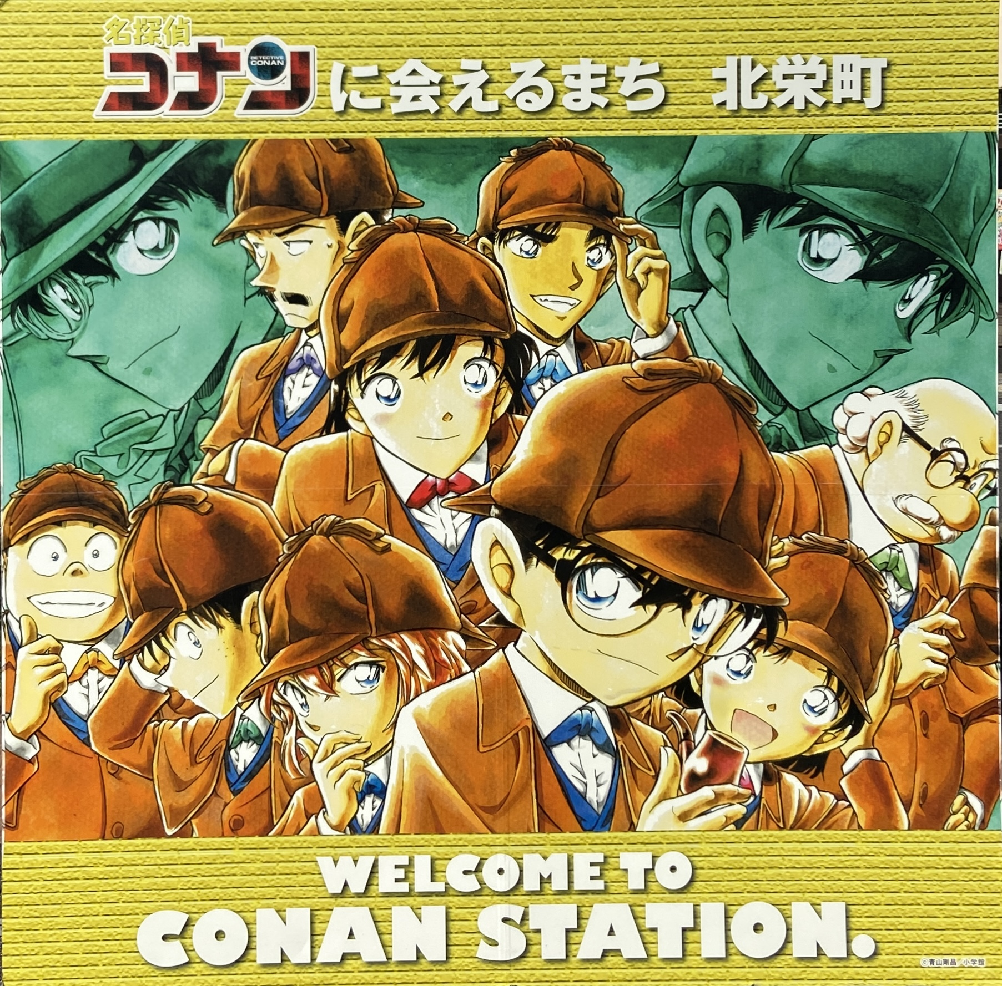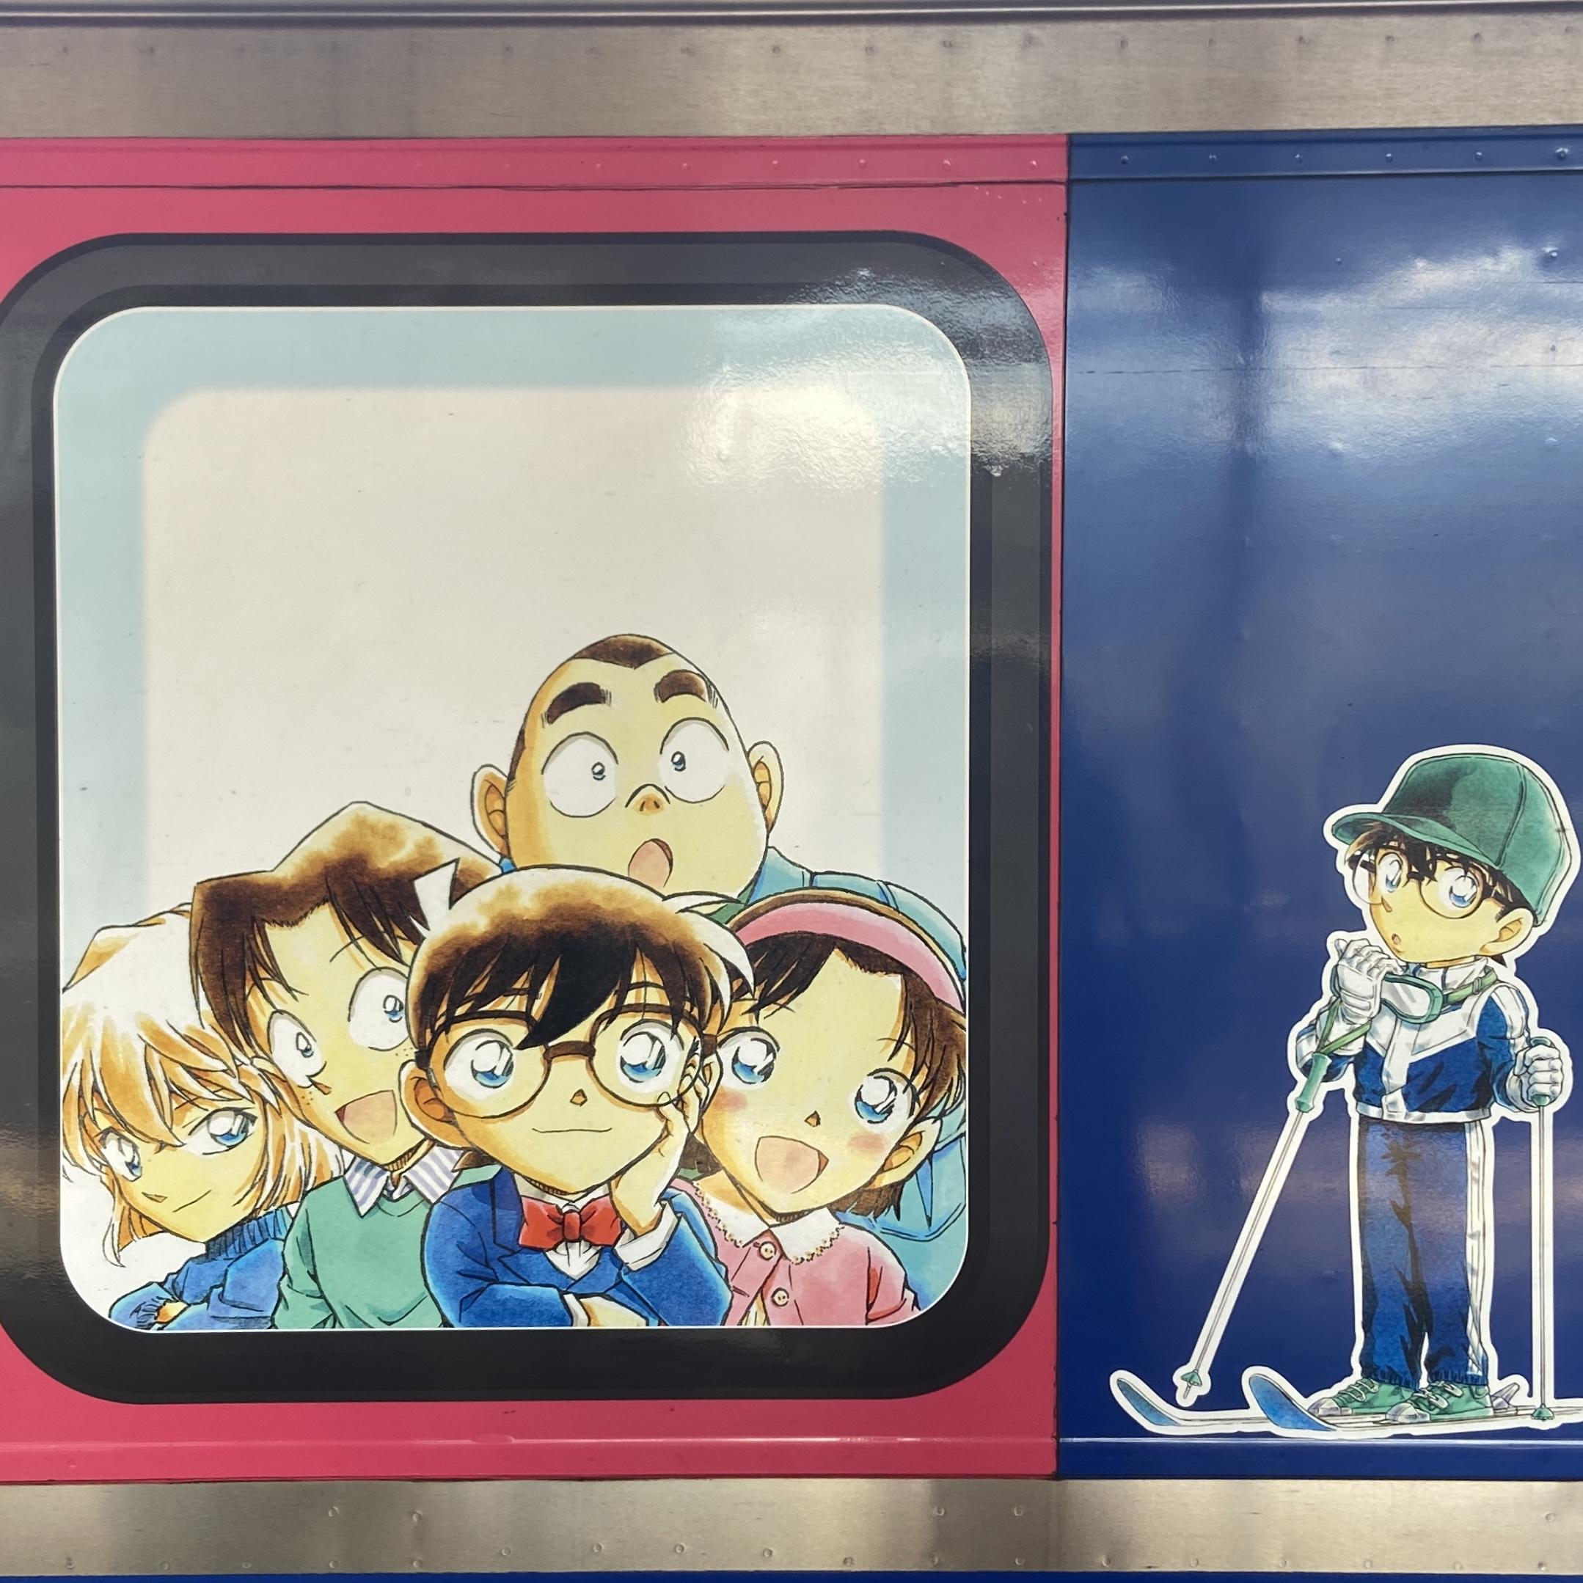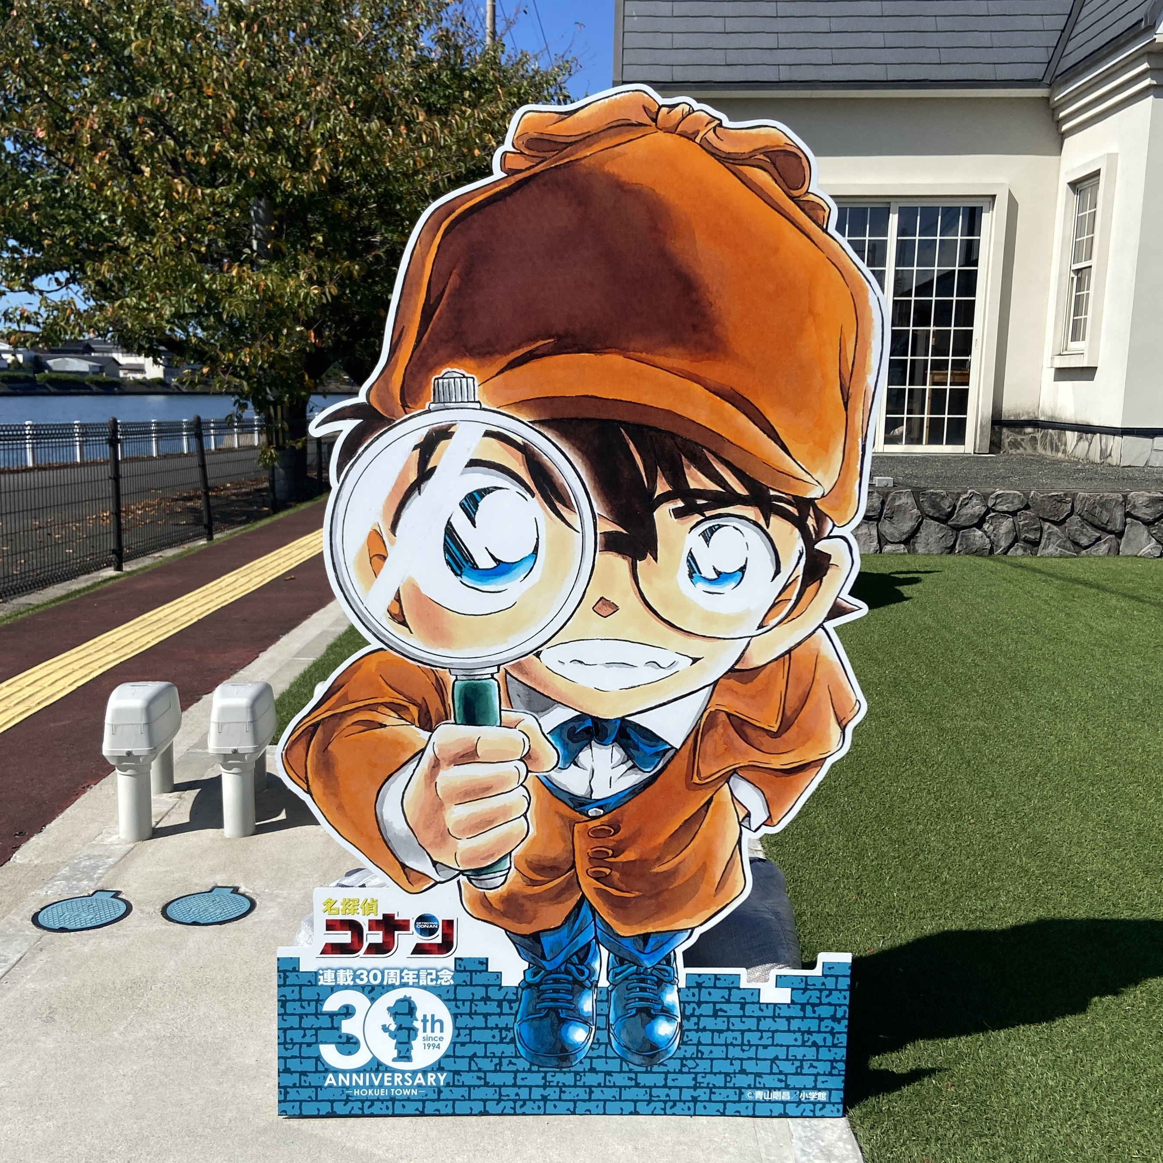

Child Page 1

Title: Exclusive Experiences: A Fan’s Pilgrimage

Intro: This is where the real investigation begins. Forget the generic guidebooks—this section is all about the exclusive experiences I uncovered in Conan Town. These are the highly personal moments that made the pilgrimage truly unforgettable.

1. Conan Street & The Great Stamp Hunt

The path from Yura Station to the Gosho Aoyama Manga Factory (Museum) is famously known as Conan Street. I highly recommend buying a stamp book at Yura Station to collect unique stamps along the route. The street is lined with statues of characters and famous comic book covers. Even the manhole covers feature different illustrations of Conan! It truly feels like walking through the manga itself.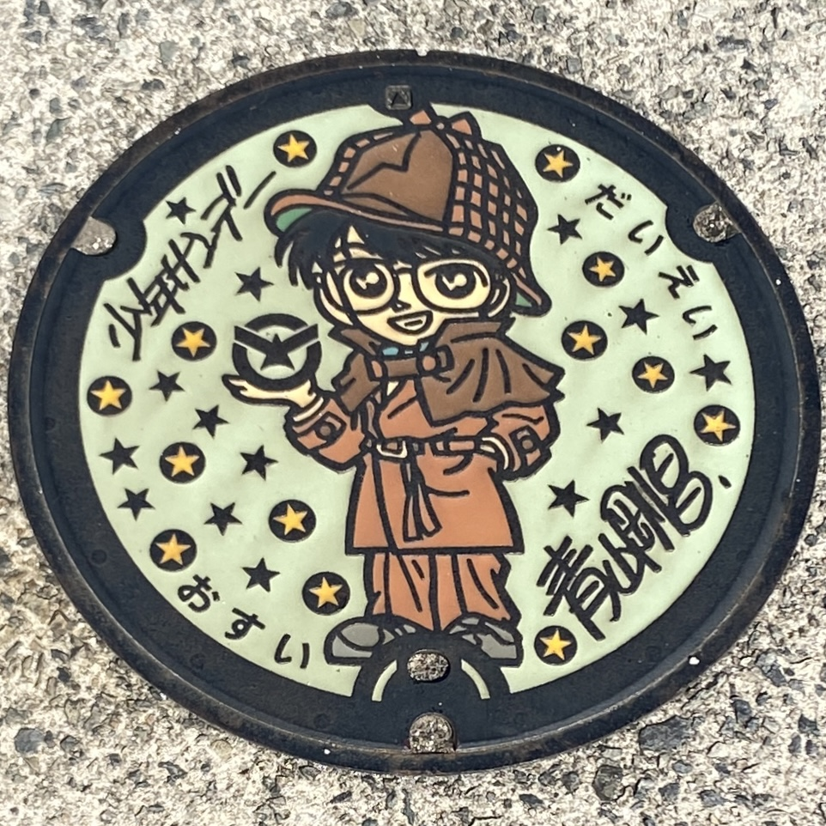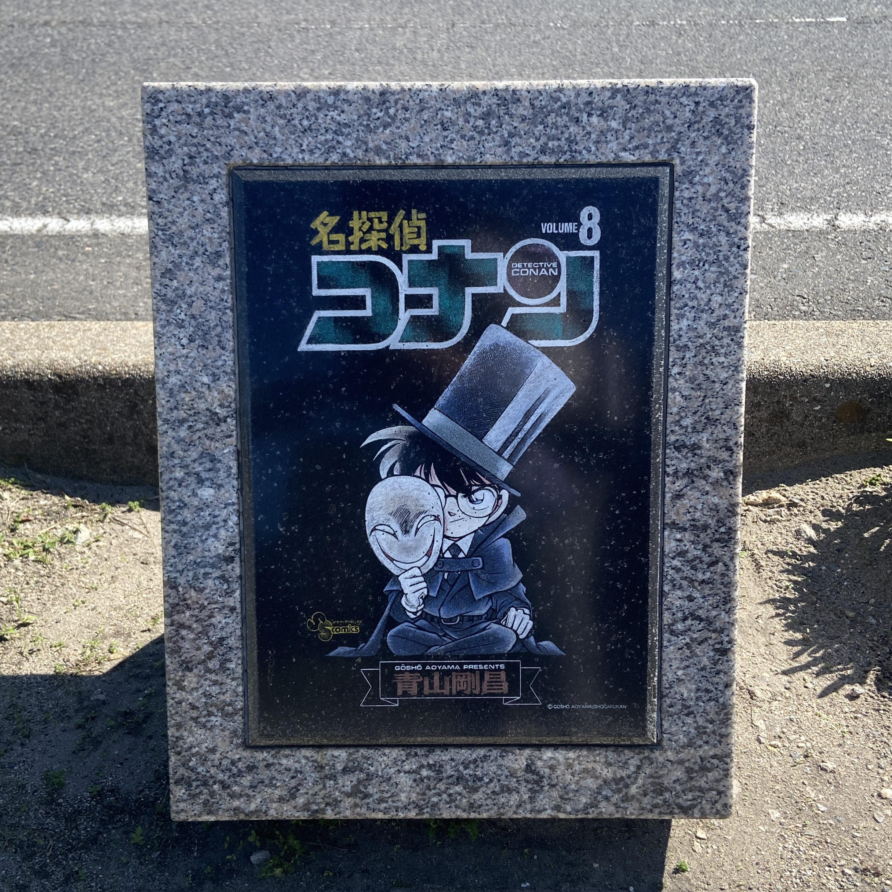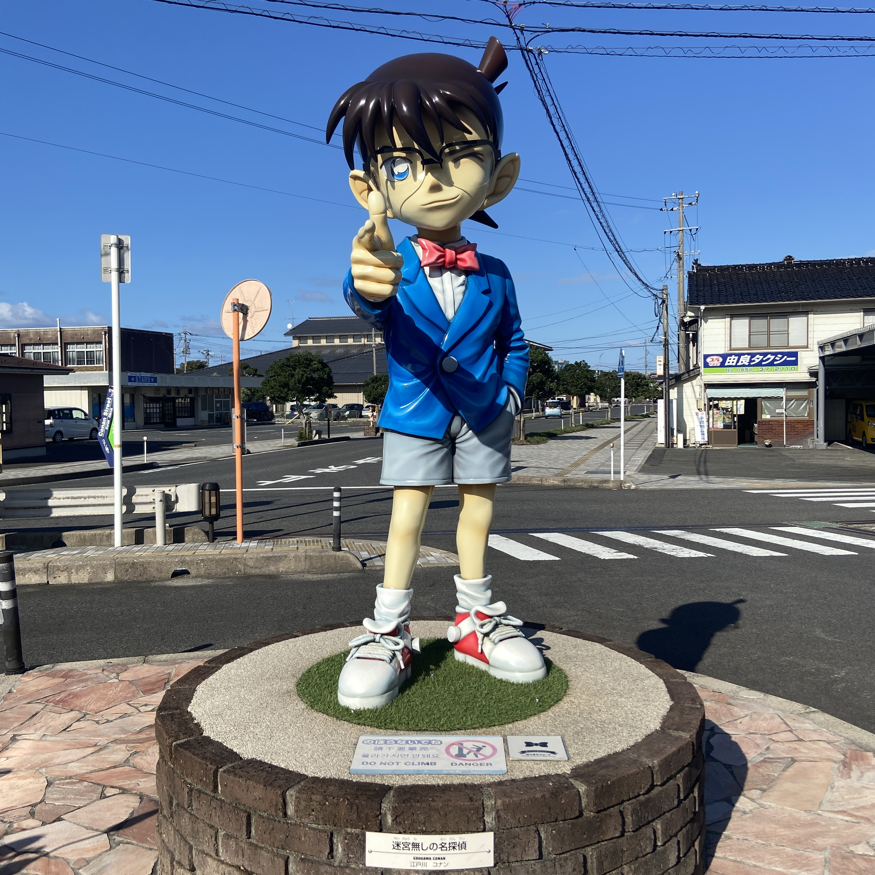

2. Conan-Themed Restaurants & Souvenirs

Located centrally on Conan Street, you’ll find several themed stores and restaurants. The souvenir shops are great for finding exclusive keychains, badges, and gift sets that are only available in Tottori. The highlight of the Conan Restaurant is the specialty Tōru Amuro sandwich, which is a 100% reproduction of the dish seen in the anime—a true treat for any fan!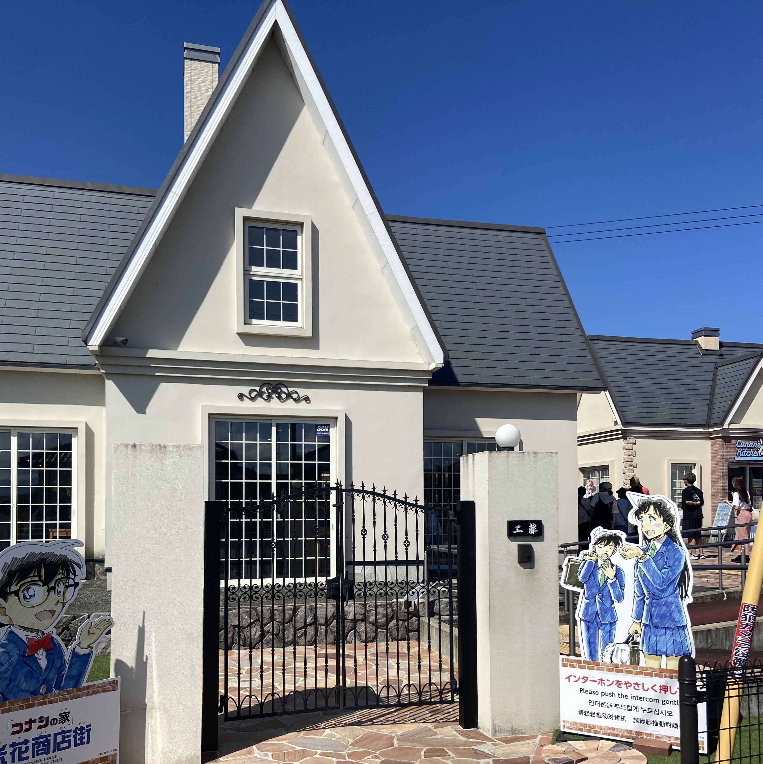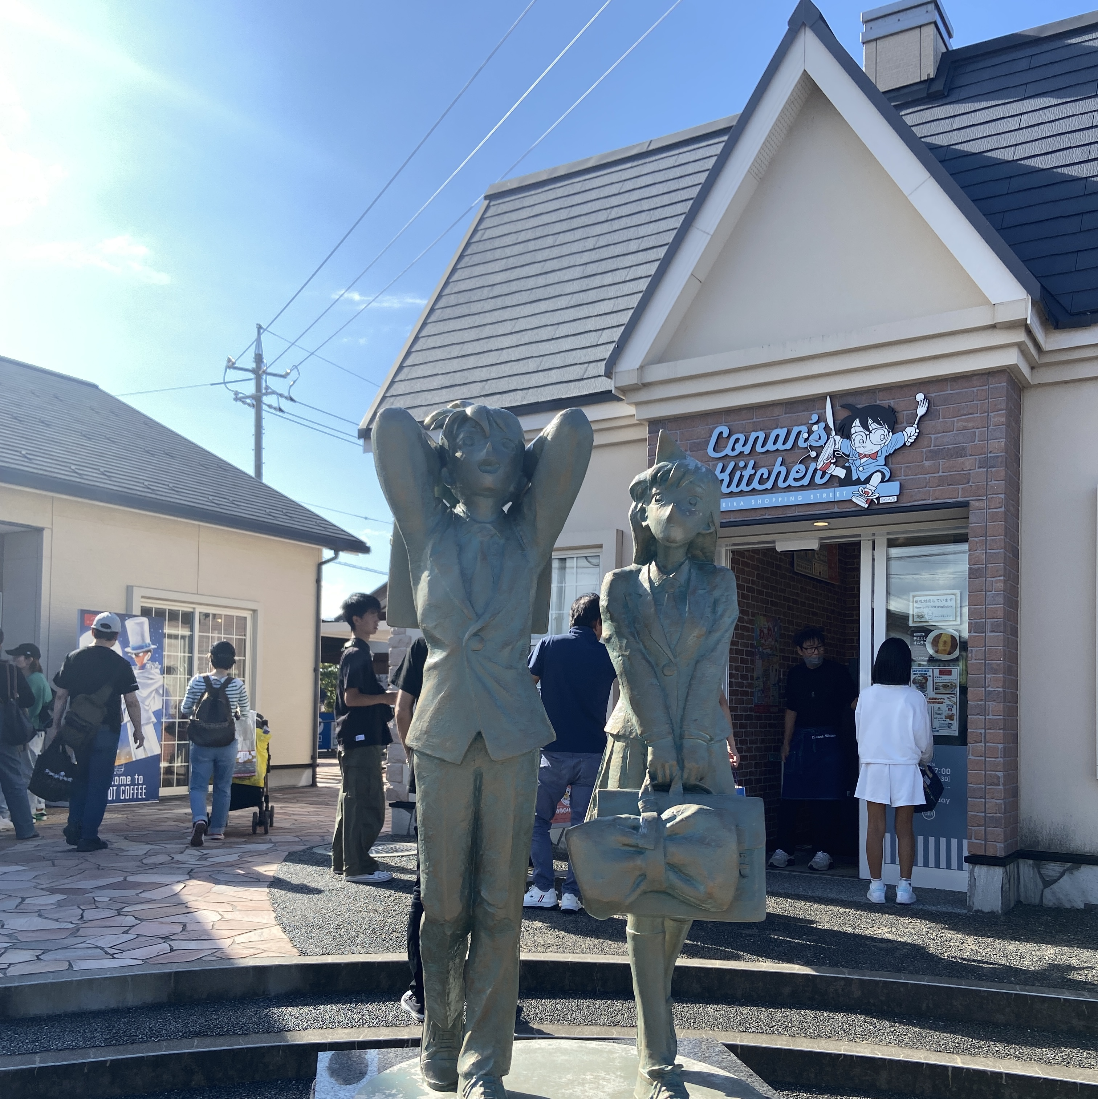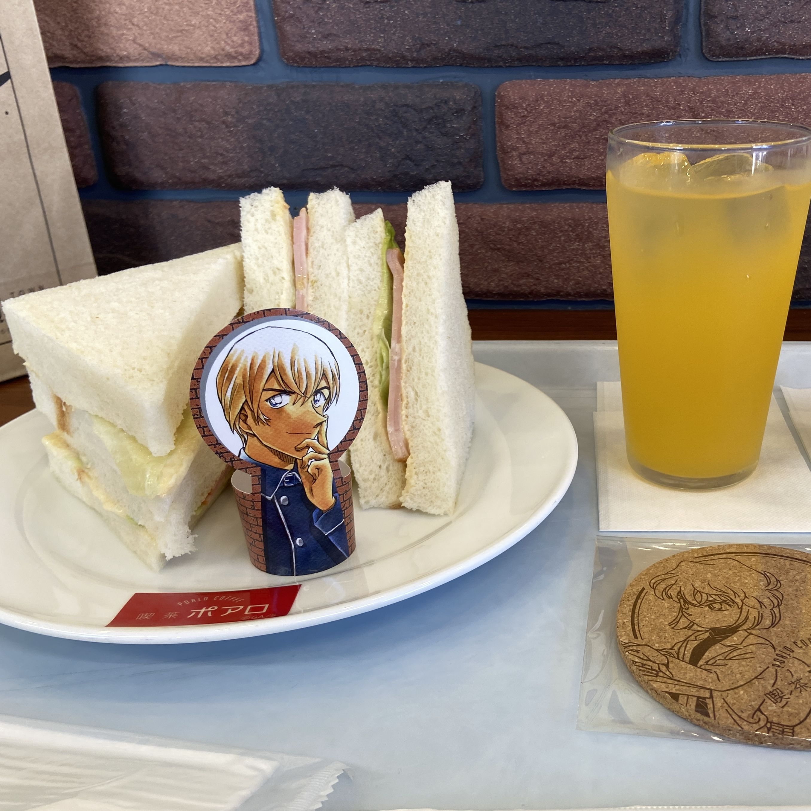

3. Gosho Aoyama Manga Factory (Museum)

This museum showcases the author Aoyama-sensei's original scripts and various settings that have appeared in the animation. Visitors can take different levels of quizzes to solve a mystery within the museum. *(I only managed to earn the beginner certificate on my visit!)* Please note: Many areas are not allowed for photography, presumably to protect the original scripts and artwork. Be sure to check out the store at the exit, as they also sell many unique, Tottori-exclusive goods.

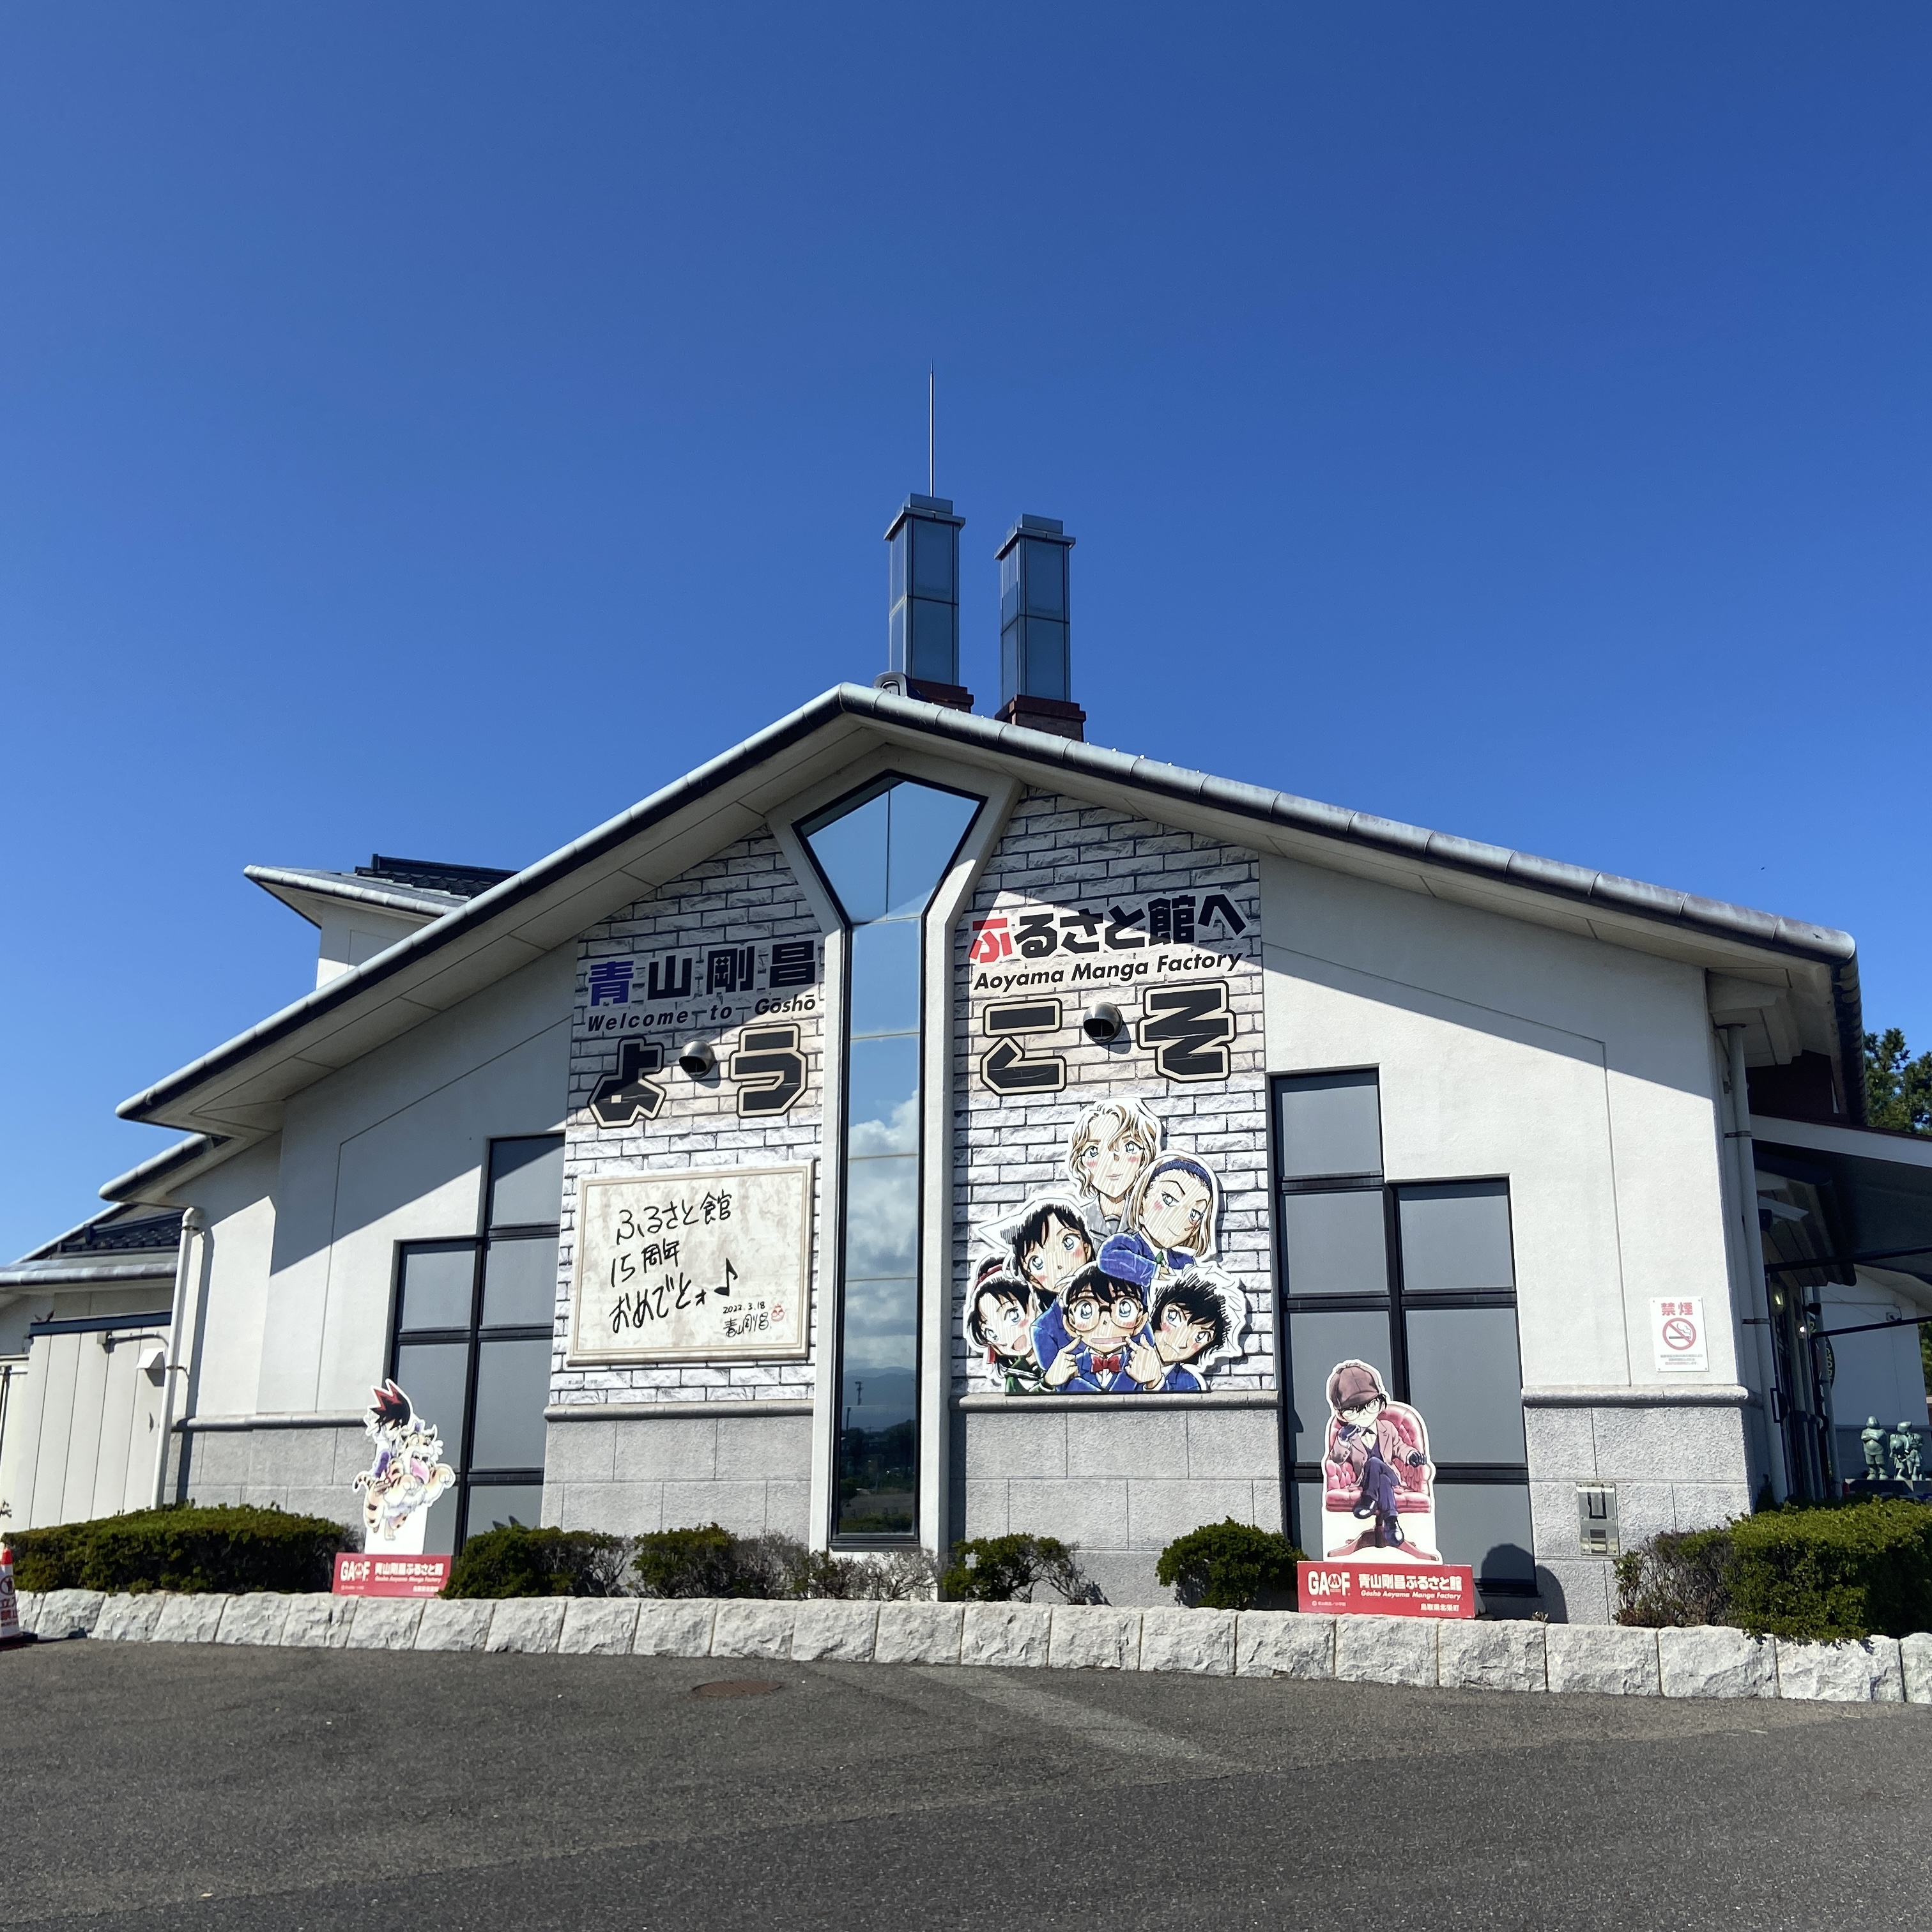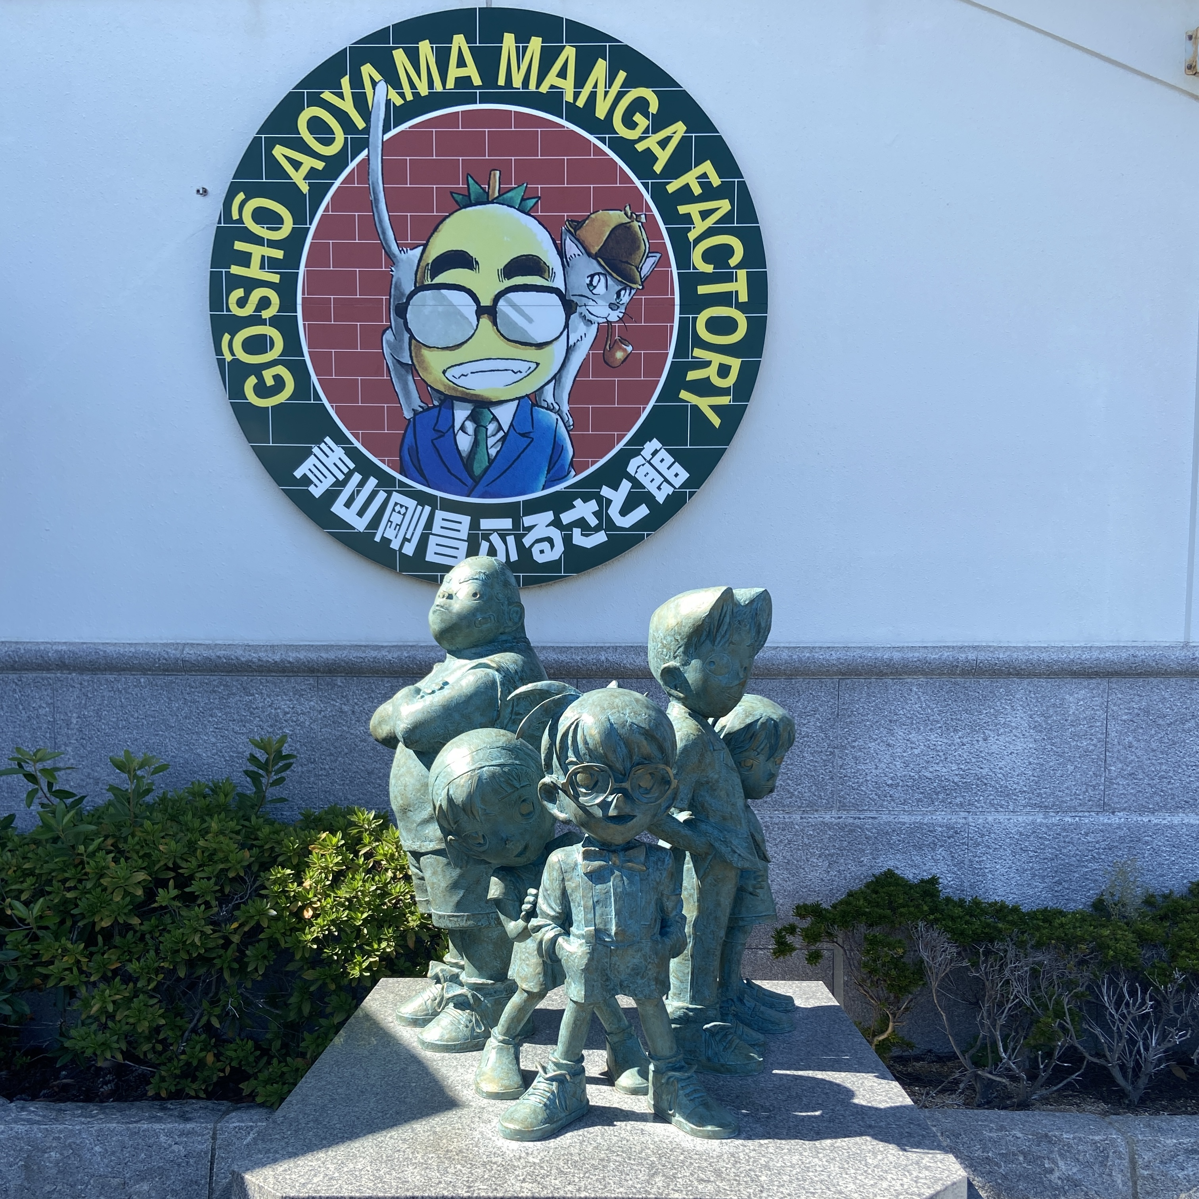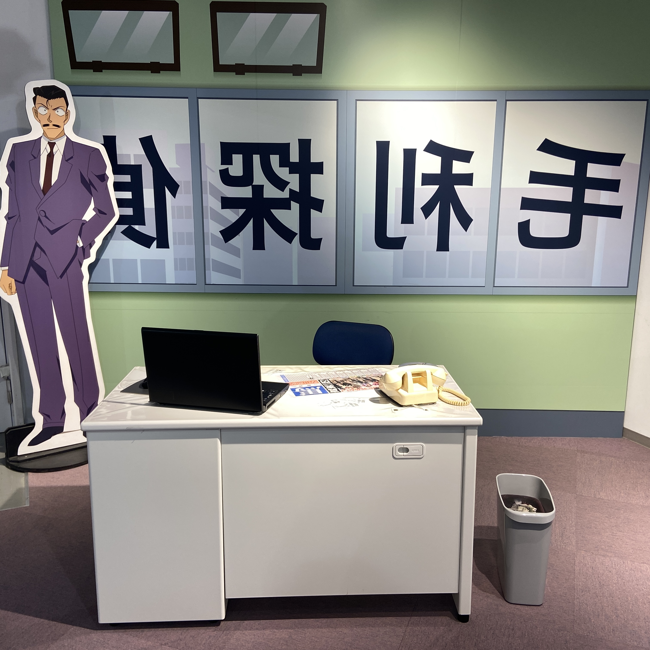

Child Page 2

Title: Practical Tips: Navigating Tottori & Beyond

Intro: Japan is known for being a conservative and highly organized country. As a foreign traveler, there are a few important things to pay attention to to ensure a smooth trip.

1. Transportation: Riding the Right Rail

Japan's railway system can be complicated, often having different express lines and normal lines. Always double-check which line you are taking. I highly recommend using Google Maps to verify the exact arrival times.

My Experience: I booked the *Hakuto Express* in advance to ensure I got the special Conan-themed coating train. After transferring in Tottori, I knew I arrived when the train arriving at Conan Town began playing the *Detective Conan*theme song!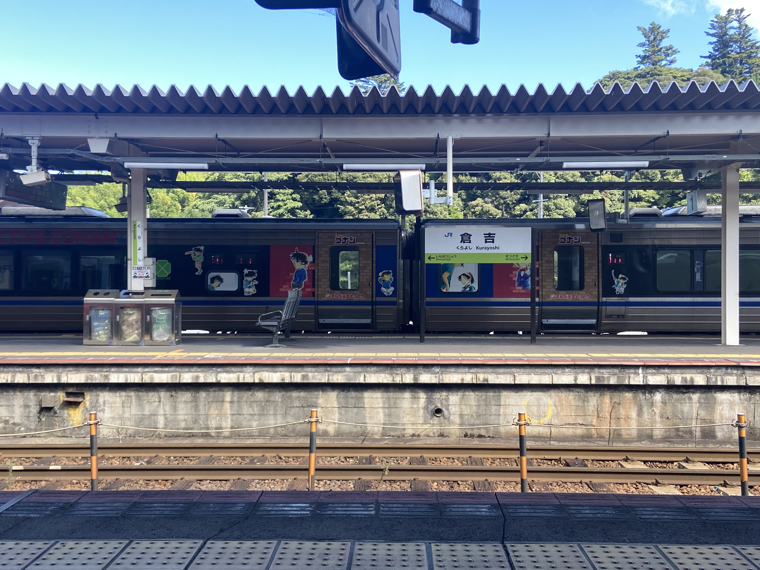

2. Accommodation: The Onsen Stay

Since there aren't many hotel options directly in Conan Town, I chose to stay in Himeji. Make sure you also book the hotel that is close to the station! The hotel was relatively cheap and included two buffets daily (breakfast and dinner). Crucially, it featured a traditional Japanese Onsen (hot spring). Remember to strictly follow Japanese Onsen etiquette when enjoying the bath!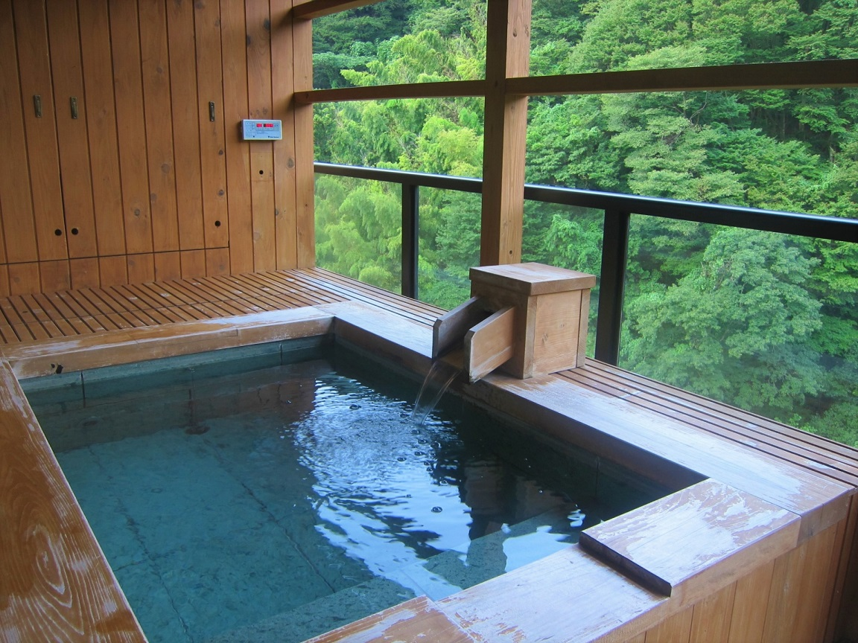

3. Currency: Cash is King

While e-wallets are widely accepted in many large Japanese cities, it's still essential to carry cash. I recommend bringing around ¥10,000 per day, plus extra for souvenir shopping. Tip: If you need coins for capsule toy machines, there is almost always a bill-to-coin exchange machine nearby.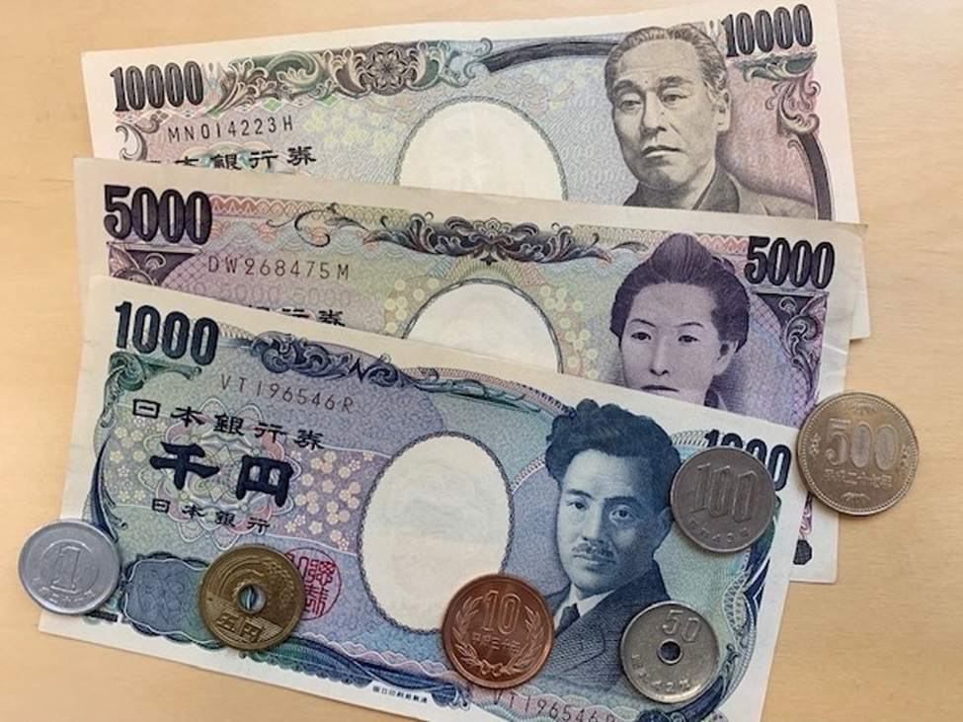

4. Language: Basic Communication

Although Japanese is distinct, the use of Kanji (Chinese characters) can sometimes make written language easier to guess for Chinese speakers. I still recommend learning a few basic phrases before your trip.If the conversation is still difficult, a polite nod goes a long way!

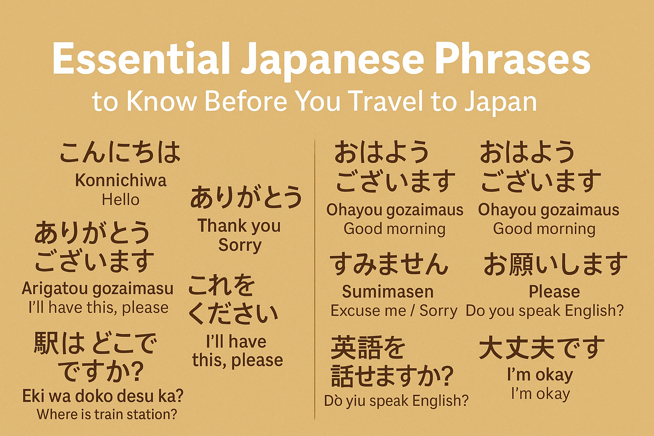

**Wireframes**

Home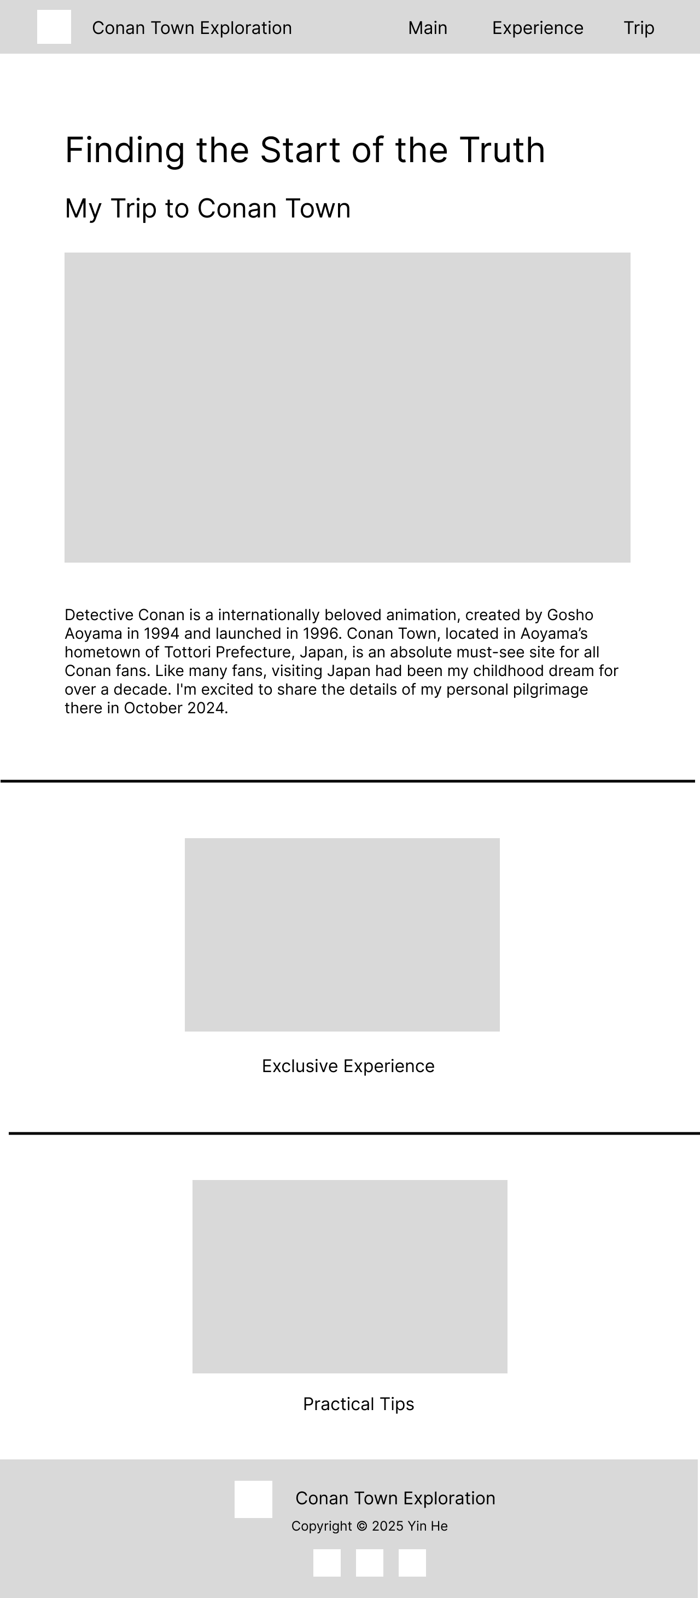

**Child Pages**